



January 2018

Young children are savvy explorers, investigating God’s creation with unbridled enthusiasm and fearless questions. Their imagination allows them to experiment with thoughts, feelings, and ideas. Imagination is also a powerful tool for discovering faith concepts. Without consistent opportunities, however, curiosity and imagination plummet by the preteen years.

Likewise, creativity often becomes less important to kids as they grow—and as they progress through the educational system. Yet that skill is an effective way to help children develop a relationship with Jesus.

“Kids can’t literally hug Jesus or sit on his lap, [so] creativity helps bridge that gap,” says Jeff White, author of Holy Wow (Group). Creativity lets kids “explore God and understand who he is, whether through art, music, food, drama, storytelling, or other forms of self-expression,” he adds.

Jesus adored and welcomed little children; in fact, he instructs us all to have a childlike faith (see Matthew 18:3). That type of faith is trusting yet curious. It asks questions, seeks new insights, and wonders how Jesus would address challenges.

Nurturing children’s curiosity and creativity provides a solid foundation for learning, living, and loving. The ultimate goal of an inquisitive, imaginative mind is to know Jesus so we can discover how to serve and love him—and other people.

Cultivate Children’s Curiosity and Creativity

POWERSOURCE
ASK GOD:
1. To bless your children with curiosity about God and the amazing world he made.
2. To help you remain curious and creative as you parent.
3. To reveal himself to your family members in meaningful ways.


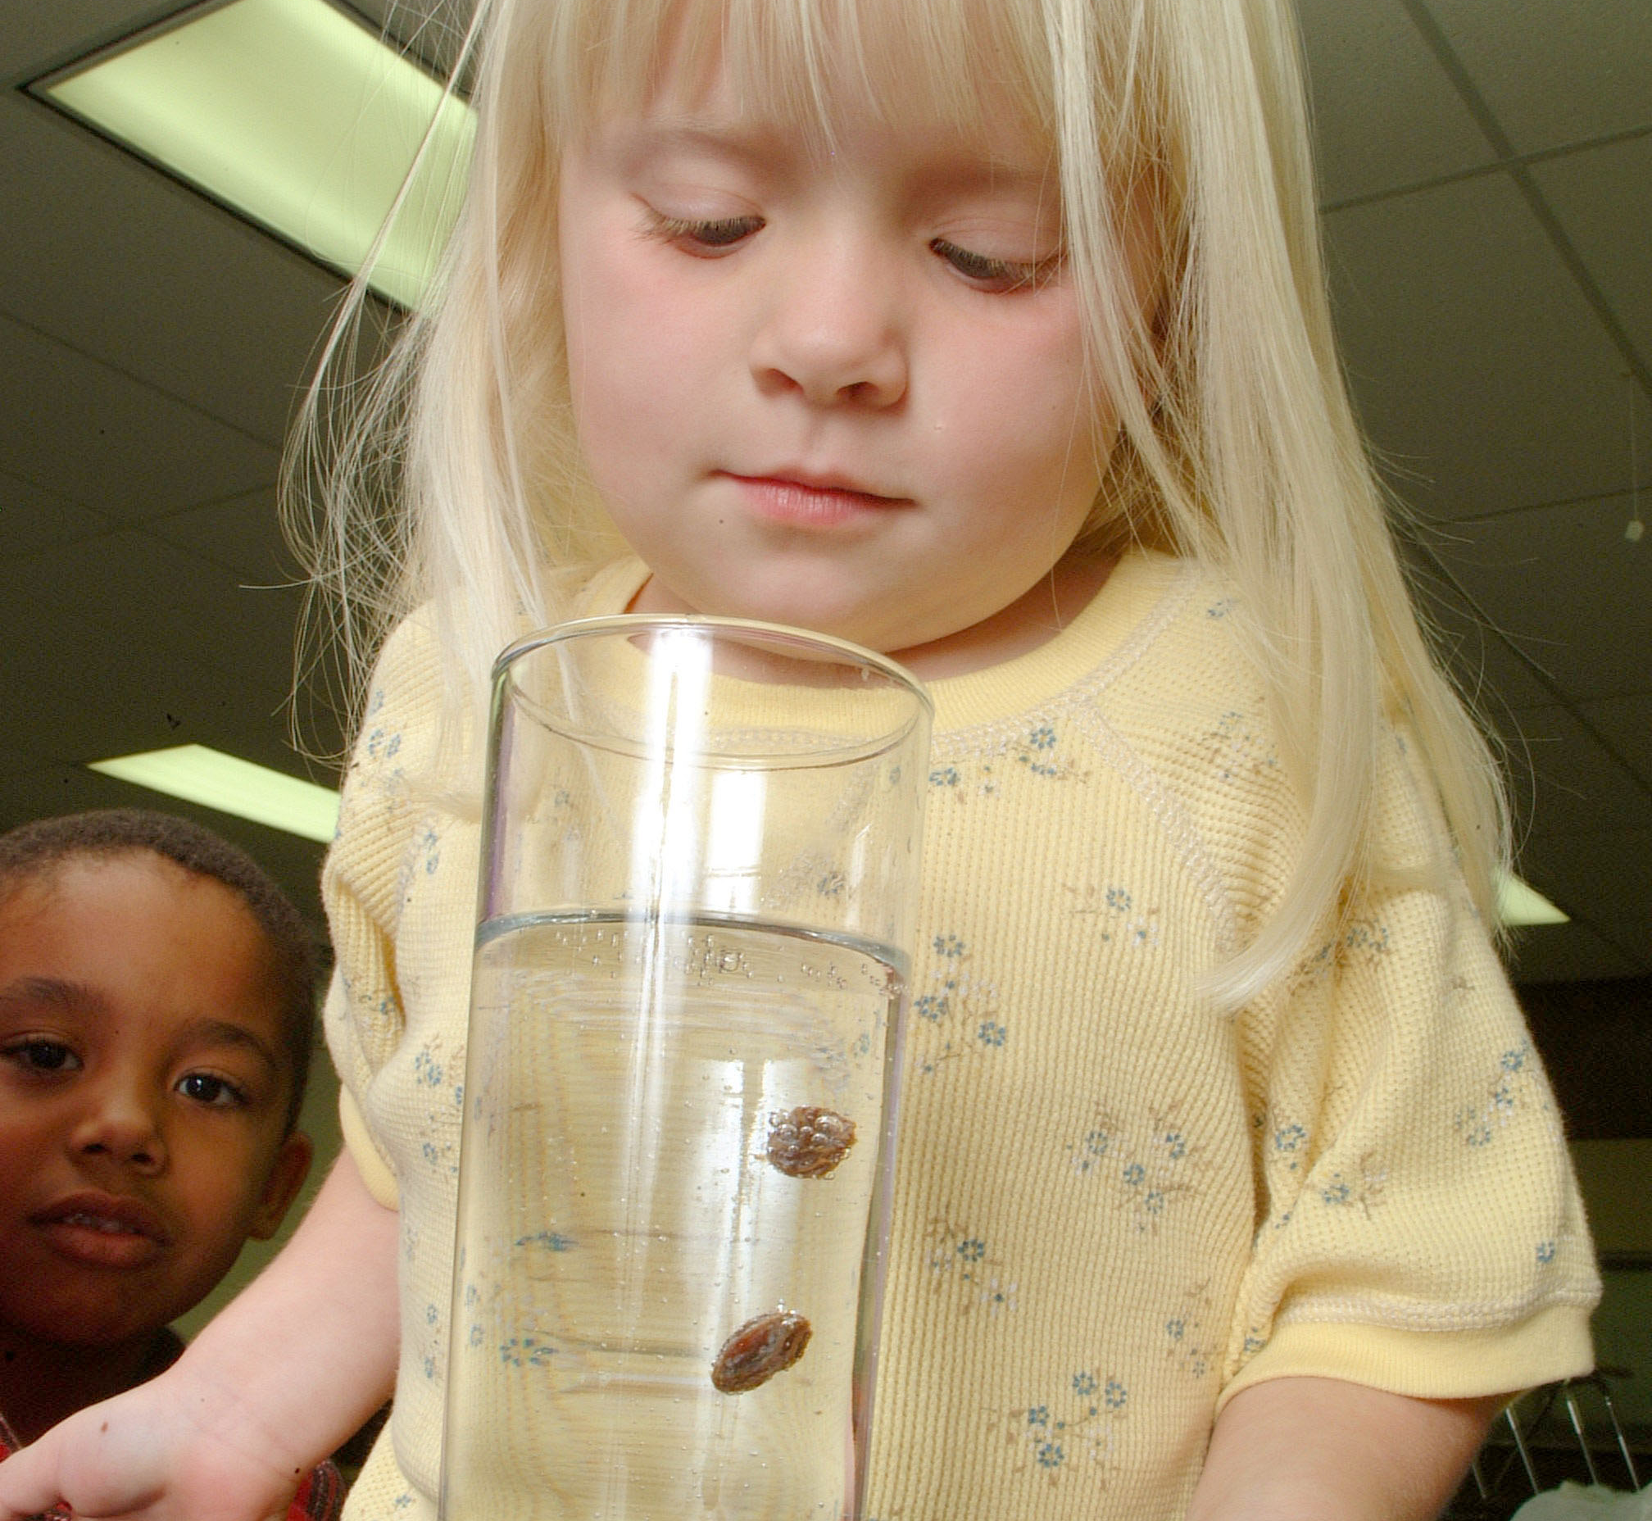
TEACHABLE
MOMENTS

Bubbling With Joy

You’ll need a Bible, a clear glass filled with carbonated soda water, raisins, and praise music.

Ask: What kinds of things make you burst with excitement?

Read aloud Psalm 100. Say: God wants us to be filled with joy when we praise and worship him.

Give each family member several raisins. Take turns dropping raisins in the glass while music plays.
When the raisins start bouncing around, say: The raisins are reacting to a gas called carbon dioxide. Tiny bubbles form on the raisins, lifting them up. When a raisin reaches the top of the water, the bubbles pop, and the raisin sinks. Then the process starts again.
Ask: How can worshiping God make us bubble up with joy?
Close in prayer—and then dance to the praise music!
ClClo

It’s a Draw Set out art supplies and draw, paint, or sculpt Bible events. Celebrate children’s creativity, and find opportunities to link their abstract art with God’s creation and his Word.

Action! Encourage children to engage with Bible events by acting them out together. After reading aloud from a children’s Bible or Bible storybook, dress up, role- play, and improvise dialogue. Allow embellishment and laughter.

Creative Creation Together, brainstorm things God created. Read aloud Genesis 1:27. Say: “Because we’re made in God’s image, we’re creative too!” Set out shapes cut from different colors of construction paper. Have family members design pictures of God’s creation (animals, flowers, people, and so on).

Curious Questions While reading the Bible together, encourage children’s curiosity by asking questions such as “How might [Bible person] tell about this event? What do you think he or she saw? smelled? tasted? touched? What other choices did this person have? What in these Bible verses do you want to do? What do you not want to do?”
Make Merry Create homemade tambourines and then make joyful noises of worship to God. Sing and dance, waving ribbons for extra effects. Older kids can write songs about a Bible passage.

STEM Stimulation Incorporate other subjects into Bible time. Use math to demonstrate 40 days of the flood, 40 days of temptation, or forgiving 70 times 7. Do research to find out what’s in a drop of pond water. Use blocks to build the Tower of Babel or the Temple.

Snacks Make Things “Stick” Research shows that snacks affect children’s memories because food connects to emotions. So make and enjoy Bible-themed snacks that tie into lessons. Use animal crackers, goldfish crackers, blue gelatin (for water), marshmallows (for sheep), and so on. Search online for easy recipes related to each lesson.

Everyday Examples Use a variety of household items to reinforce Bible truths. For example, place a dried-up sponge in a pan of water and discuss the changes that take place in us when we know Jesus. Pull some tissues out of a box and explain how the church is a bunch of people holding up one another.

“O Sovereign Lord! You made the heavens and earth by your strong hand and powerful arm. Nothing is too hard for you!”
—Jeremiah 32:17, NLT

Spark the Joy of Discovery

Spending time with children can be unpredictable—and can lead to many God-moments. Through their vivid imaginations, children become part of God’s unfolding story with a sense of innocence and trust that we lose as adults. There’s no rush to confront little ones with reality; that happens soon enough. Set aside criticism, competition, structure, and comparisons. Instead, emphasize praise, acceptance, freedom, insights, and smiles. Rushing squelches curiosity, so allow plenty of time for your children to make and share their discoveries. Welcome their questions, even if you don’t have all the answers. And remember to show curiosity yourself, because that mindset is contagious! Try these ideas for revealing biblical truths through imagination and creative exploration.

Games, Sites & Apps

MEDIA MADNESS

This page is designed to help educate parents and isn’t meant to endorse any movie, music, or product. Our prayer is that you’ll make informed decisions about what your children watch, read, listen to, and play.
I Got This!
In this active board game, players earn points by completing funny and sometimes tricky challenges. The tasks help build gross motor skills, critical thinking, coordination, and cooperative play. The game, available from Fat Brain Toys, is best for ages 8 and up.

brainson.org
This kid-friendly website offers information about a wide range of science-related topics. On a weekly podcast that mixes facts with humor, scientists discuss topics from planets to curious-looking creatures. Although the 15- to 30-minute episodes are silly, they capture children’s interest.
Color Switch
In this simple, fast-paced game, players tap a ball through spinning, geometric-shaped obstacles by matching color patterns. The free app, for kids ages 4 and up, has 25 levels in six modes. Note that some ads attached to the app may be inappropriate or may freeze the game.

CULTURE
& TRENDS
Time Off for Pops More companies are following the example of tech giants by offering paid paternity leave. States such as California and New Jersey have formalized up to six weeks of paid leave for new dads. Many fathers, however, feel pressure not to take it. (cnbc.com)

One and Done To try to keep families safe on the road, a New York restaurant is enforcing a one-drink limit on parents who dine with their kids. (time.com)

QUICK STATS
Tiny (Digital) Footprints About 92% of U.S. children younger than 2 already have an online footprint. Some parents even check the availability of domain names and social media handles when choosing baby names. (chicagotribune.com)

Up in Smoke Two-thirds of preteens and teens say the legal age for purchasing cigarettes should be raised from 18 to 21. (pediatrics.aapublications.org)

Adoption Trends In the past dozen years, international adoptions by U.S. parents have declined 77%. And for the first time on record, boys now outnumber girls among international adoptees, mainly due to changes in China. (pewresearch.org)

MOVIE

Title: Jumanji: Welcome to the Jungle
Genre: Action, Adventure, Comedy
Rating: PG-13
Cast: Dwayne Johnson, Jack Black, Kevin Hart, Karen Gillan
Synopsis: In this stand-alone sequel to the 1995 Robin Williams movie, four teens are pulled into the jungle setting of an old video game. Trapped in the adult bodies of their chosen avatars, they must embark on a dangerous adventure to return to the real world.
Our Take: This film explores how games can literally suck you in. Because the characters play against type, families can discuss how people view themselves and others. The movie isn’t for younger children, due to thematic elements and scenes of peril.

MUSIC

Title: Crooked
Artist: Propaganda
Synopsis: This rapper and social activist, also known as “Props,” challenges listeners with bold lyrics about his relationship with God and society. Crooked, his fifth album, is a mix of rap, hip-hop, and poetry set to a beat. Its style is in line with pop culture, yet the songs are full of thought, American history, and the gospel.
Our Take: Like Lecrae, Props appeals to young listeners because of his mainstream sound. Yet he focuses on important social and spiritual questions, rather than violence, materialism, and hypersexuality. Crooked is a desirable music option for preteens and parents alike.

January

SUNDAY | MONDAY | TUESDAY | WEDNESDAY | THURSDAY | FRIDAY | SATURDAY
 | 1  New Year’s Day | 2 | 3 | 4  Donella Ray’s Bday | 5 | 6
7 | 8 | 9 | 10 | 11 | 12  Youth Winter Retreat | 13  Youth Winter  Retreat
14  NLO | 15  Martin Luther King Jr. Day | 16 | 17 | 18 | 19 | 20
21 | 22 | 23 | 24 | 25 | 26 | 27
28  $20 Kids Camp Deposit Due | 29 | 30 | 31

