


October 2018

One of the most powerful ways parents can convey biblical truth to their kids is by using Jesus’ parables. And a significant portion of Jesus’ lessons were about money—more specifically, about being faithful stewards of all our God-given resources.

Christian stewardship involves more than just putting money in the offering plate or pledging donations to charities. Through his teaching, Jesus reveals that stewards must wisely manage time and talents, as well as financial resources. That involves using those resources to serve God and other people.

From a young age, children observe their parents’ financial habits and learn about the role of money. It’s important to model Bible-based attitudes about saving, spending, and giving. When we’re honest about everything from daily transactions to yearly tax returns, we demonstrate how to be trustworthy. And when we give to church, charities, and neighbors in need, we teach the joy of from-the-heart generosity.

Financial experts recommend using an allowance system that works for your family so children can save for the future, spend some of their earnings, and donate a portion as well. Such habits set the foundation for a lifetime of financial stability as well as God-honoring stewardship.

Read on for ideas about teaching children of all ages the priceless value of Christian stewardship.

Set a Foundation for Faithful Stewardship


POWERSOURCE
ASK JESUS:
1. To show your children how to be trustworthy stewards of their time, talents, and treasures.
2. To help you set strong examples of Christian stewardship in your home and community.
3. To allow you and your kids to give willingly and cheerfully.

Please sign up for our Fall Festival/Trunk or Treat, Oct. 31 from 6-8

https://www.signupgenius.com/go/10C0D4FADA62CA6FD0-fall1

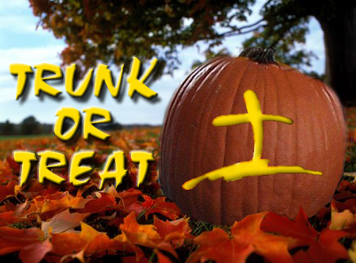

TEACHABLE
MOMENTS

Investments With Dividends

Out of your family’s sight, put five scoops of sand in a paper lunch bag labeled “Servant 1.” Put two scoops of sand in a bag labeled “Servant 2.” Leave a bag labeled “Servant 3” empty. On top of the sand in bags #1 and #2 only, insert another open, empty bag with a hidden slice along one bottom edge. Then fold the edges of all bags outward so they look identical.

As you read aloud Matthew 25:14-18, pause to let family members measure scoops of sand equal to how much the master gave Servant 1, 2, and 3 and add them to the proper bags. Then read verses 19-25. As each servant shows his earnings, cut the bottom of the outer bag (on the same side as the inner slice) and pour out the sand from that servant's bag. Keep the piles separate. (Ensure all the hidden sand from bags #1 and #2 comes out.)

Use the scoop to measure how much sand is in each pile now. Say: The first two servants returned with more money because they invested it wisely. But the third servant made a poor decision.

Read aloud Matthew 25:26-28. Discuss how you can wisely use and invest the gifts God gives you.

Get to the Heart of Giving

Many children—and adults—are motivated to give sacrificially when their hearts are broken by a need they see or experience. We want to make a
difference by mending other people’s hearts, and we want our giving from the heart to touch the world. Point to and discuss current needs in your town and beyond. Then discuss ways your family can make a practical difference. Be honest with kids about the role of money in fulfilling God’s mission. Even though God doesn’t need our money (he’s that powerful!), the church does. God uses our giving to minister to others. The church and missionaries use our money to help others know Jesus. That’s how God set it up. His work needs his people’s gifts—even children’s!

“No one can serve two masters…. You cannot serve God and be enslaved to money.”
—Matthew 6:24

Mighty Mites Read aloud Luke 21:1-4 and talk about the poor widow who donated two “mites,” or small coins, to the temple. Make crayon rubbings of various coins and display them throughout your house. Ask: “What does it mean to give God everything we have? What positive and negative attitudes do some people have about giving money to God or to other people? How can we share our blessings from God in a cheerful way?”

Plant Seeds Entrust children with “seed money,” based on Jesus’ parable of the talents. Brainstorm ways to make that money grow, and then use it to help as many people as possible. For example, set up an apple-cider stand, and use the proceeds to buy gloves and scarves for homeless people.

Give It Away Give each family member six gift bows to stick on their clothing. Say: “When I say, ‘Give a gift,’ try to give away your bows by attaching them to someone else’s clothes. The goal is to give away all your bows without receiving any.” After playing, discuss what it was like to give—and receive—bows. Read aloud Malachi 3:10. Ask: “What does this verse say about giving gifts to God? What can we give God to show him how much we love him?” Say: “We are God’s gifts to each other. Let’s always be generous and give to others.”

Mission-Minded As a family, sponsor a child through an organization such as World Vision or Compassion International. Contribute to disaster-relief efforts. Look for community service projects you can work on together.

Where’s Your Treasure? Set up a treasure hunt so children can look for real coins or candy coins. Afterward, decorate wooden “treasure chests” with paint and heart-shaped stickers. (You can find inexpensive boxes at craft stores.) Read aloud Matthew 6:21 and discuss what it means to treasure something. Ask: “What happens when we treasure our money? When it comes to money and possessions, how can we keep our hearts in the right place?”

Everyday Excursions Turn shopping trips into lessons on money management. Give kids each a shopping list and show them how to hunt for bargains, compare prices, and use coupons. Encourage kids to interact with cashiers and count change.

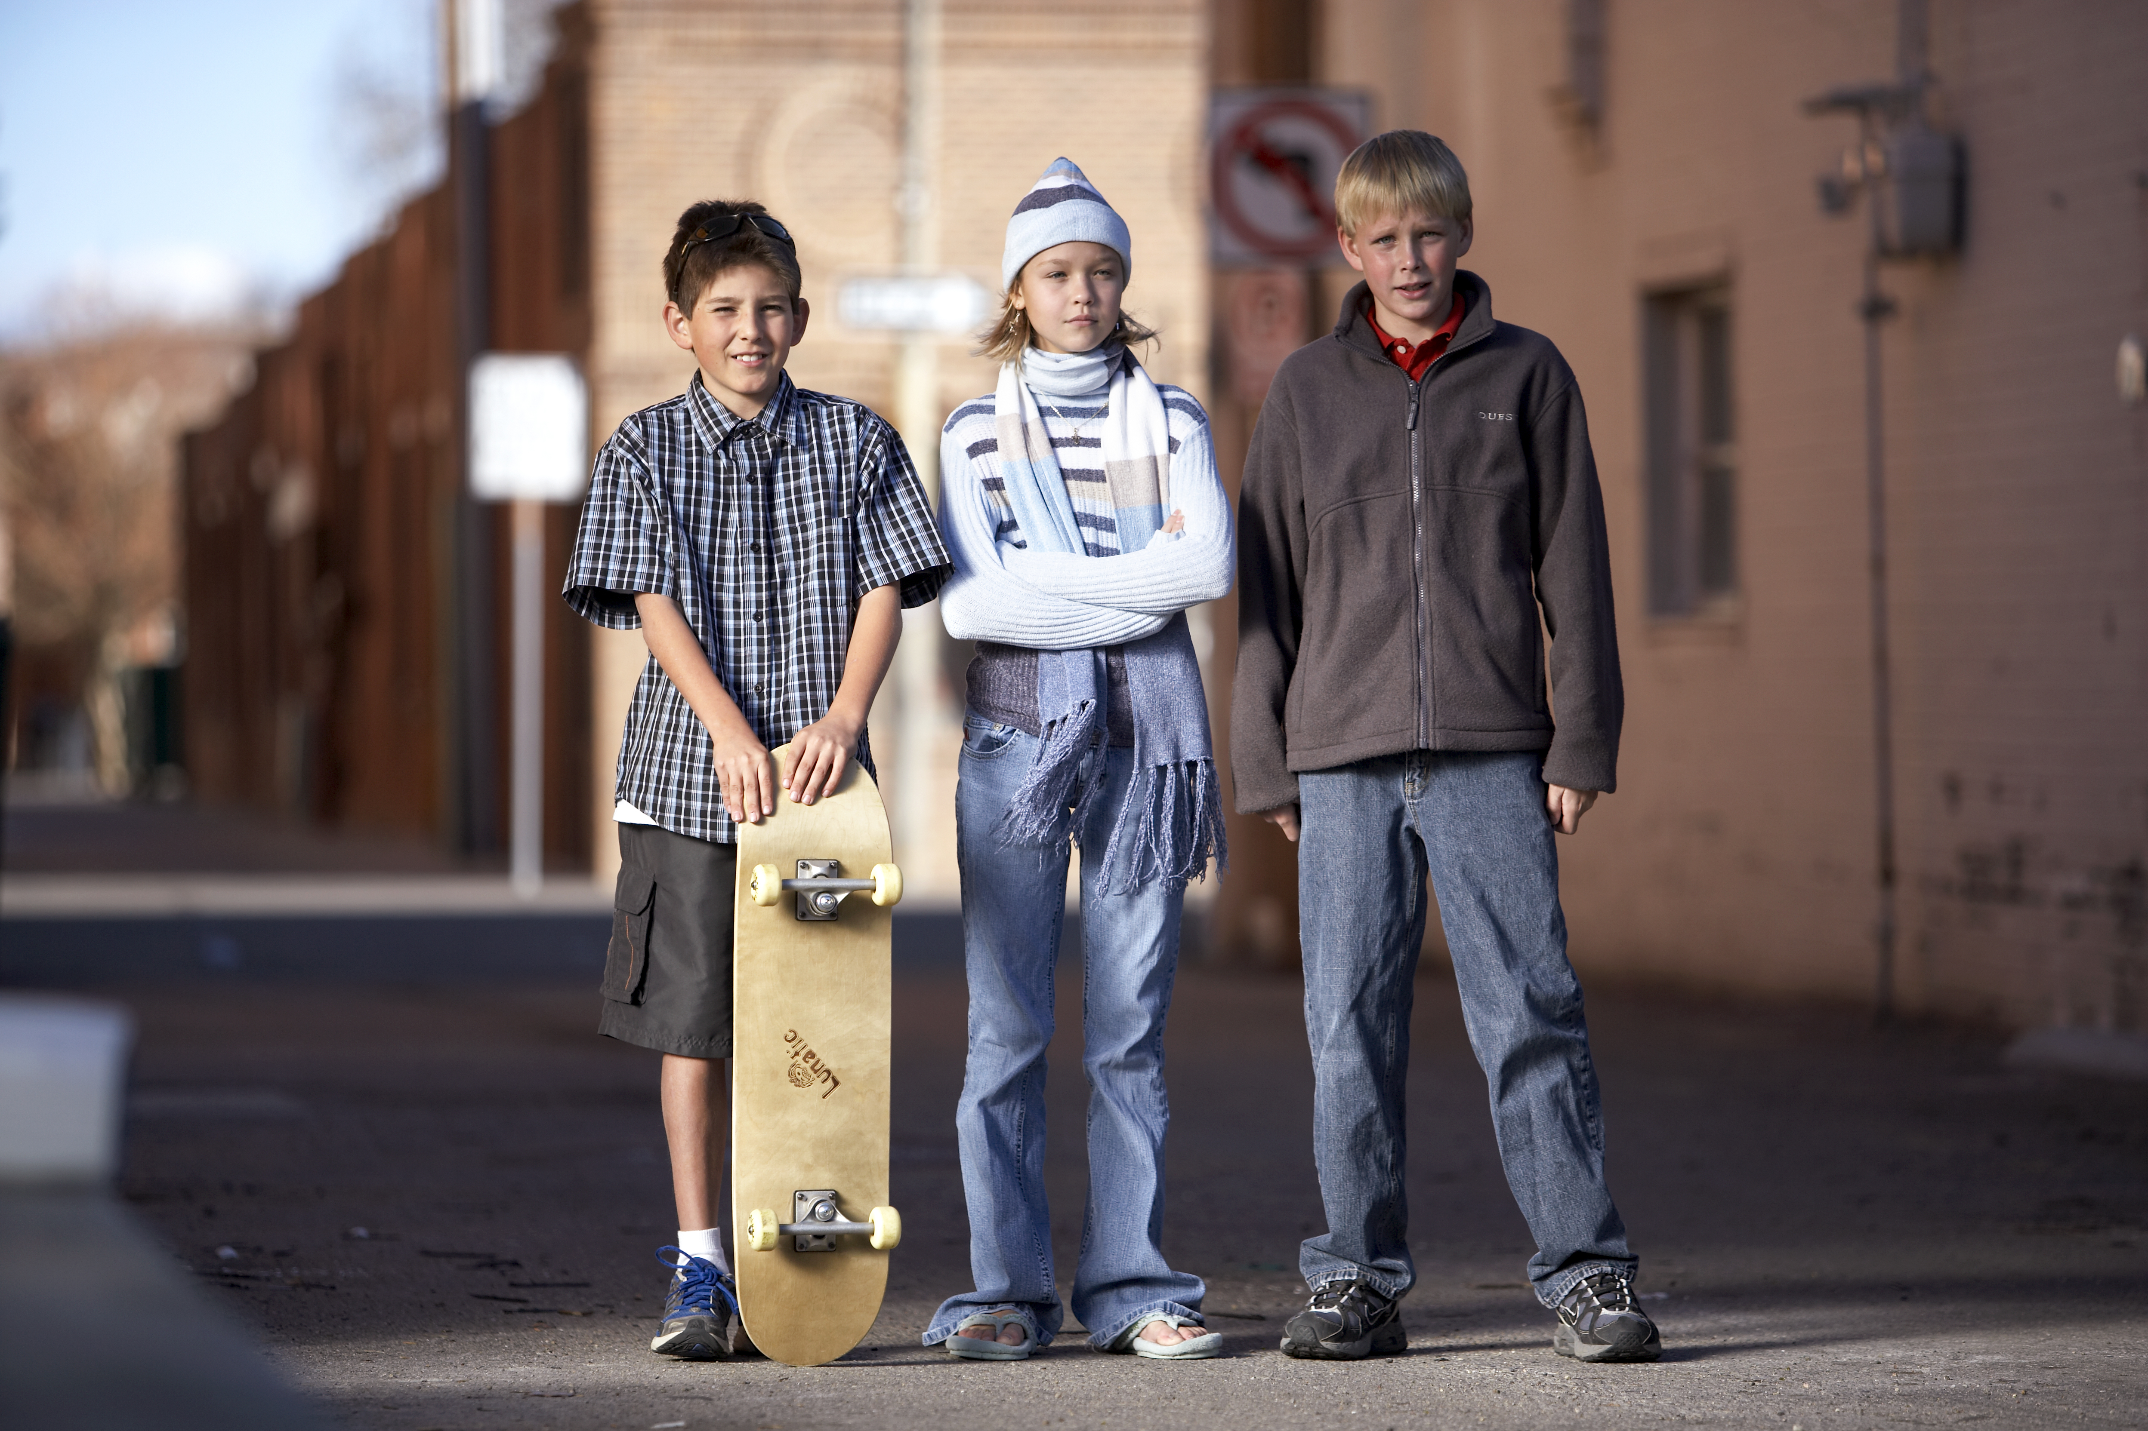

MEDIA MADNESS

CULTURE
& TRENDS
Wanted: Space to Shred Skate-boarding’s popularity continues to grow, with the sport making an Olympic debut in 2020. America has 3,500 skate parks, about one-third of what it needs, according to the Tony Hawk Foundation. (nytimes.com)

Level Up Eager to help kids improve their Fortnite performance, some parents are paying big bucks for hourly video-game tutors. Goals range from improving children’s social standing to helping them earn scholarships or even go pro. (wsj.com)

QUICK STATS
Kind Kids Although bullying still makes headlines, kindness is quite prevalent among kids today. In a recent survey, 80% of 9- to 11-year-olds say they’ve “gone out of their way to do something kind for a kid who was having a problem or feeling down.” More than one-fourth of those children say they’ve done that “many times.” (cartoonnetwork.com)

Pay Up! In the past eight years, there’s been a 26% increase in the average hourly rate U.S. parents pay baby sitters, now reaching almost $14. That doesn’t include tips, which one-third of parents say they add in. (care.com)


MUSIC

Musician: Zedd
Synopsis: DJ-producer Zedd (born Anton Zaslavski) has had 10 songs on Billboard’s Hot 100, including four in the Top 10. His specialty is the super-popular genre of EDM, or electronic dance music. Zedd partners with top pop artists such as Ariana Grande and Liam Payne.
Our Take: Dance-club music isn’t always inappropriate for preteens; even some worship music now has an EDM sound. Zedd’s songs such as “Stay” and “The Middle” don’t contain objectionable content. But because he works with a variety of artists, it’s tough to predict future content. For example, Hailee Steinfeld’s song “Starving” features Zedd, and it’s all about a sexual relationship. Use caution.
Games, Podcasts & Apps

Flat Heroes
In this minimalistic arcade game, available for PC and Switch, a player is a square and must maneuver to avoid flat-shaped obstacles. Up to four people can play simultaneously, and only one needs to survive a level in order for all players to move on. The game is rated E for Everyone.
What If World
These wacky stories, available through the Kids Listen app, are inspired by questions from real kids. Host Mr. Eric spins tales based on questions such as “What if cats ruled the world?” and “What if there were a never-ending bowl of ice cream?” The storytelling encourages creativity and imagination.
Cydia
This “jailbreak equivalent of the iOS app store” lets iPhone users get apps that aren’t available from Apple and customize their phones with them. Preteens can use Cydia to do anything from change the color of icons to watch videos on ProTube HD, which has fewer content restrictions than YouTube does.

This page is designed to help educate parents and IS NOT meant to endorse any movie, music, or product. Our prayer is that you’ll make informed decisions about what your children watch, read, listen to, and play.

October

SUNDAY | MONDAY | TUESDAY | WEDNESDAY | THURSDAY | FRIDAY | SATURDAY
 | 1 | 2 | 3 | 4 | 5 | 6
7 | 8 | 9 | 10 | 11 | 12 | 13
14 | 15 | 16 | 17 | 18 | 19 | 20
21  World Mission Sunday | 22 | 23 | 24 | 25 | 26 | 27
28 | 29 | 30 | 31  Fall Festival/Trunk or Treat  6-8



