


September 2017

For many children, a highlight of back-to-school season is reuniting with old friends and making new ones. Friends are vital to emotional and social development. Through friendships, kids learn to relate, respect, share, make decisions, and set boundaries. Having friends also boosts self-esteem by making children feel supported.

Unfortunately, peer conflicts, mistreatment, and even bullying occur even among young children. The National Education Association says 160,000 kids miss school each day because they’re afraid of bullying, attacks, or intimidation. The example you set at home can help children develop kindness, love, and respect while maintaining a healthy sense of self.
Show selfless love. Help children make the connection between how Jesus loves and cares for us and how he wants us to love and care for one another. Make the Golden Rule a priority in your home (Matthew 7:12).

Agree to disagree. Children need to hear that it’s okay to have different opinions; after all, God made us each different. But it’s never okay to hurt or mock someone with words or actions.

Know everyone matters. Focus on activities and behavior standards that are positive, fun, and rewarding in order to help children find the acceptance and recognition they seek. Guiding kids toward loving themselves is key to helping them love other people.

Read on for more friend-focused ideas!

Nurture Positive Friendships


POWERSOURCE
ASK JESUS:
1. To guide your children into positive, productive friendships.
2. To show your family members how to love and befriend one another.
3. To give your kids the strength to stand up and speak out against bullying.


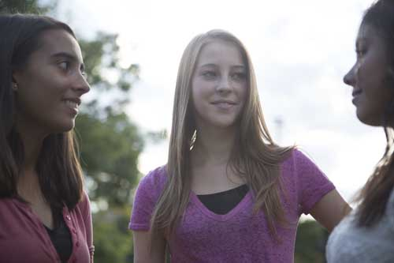
TEACHABLE
MOMENTS

Supportive Friends

Set out two piles of index cards (six cards per pile), a bag of popcorn, and a bag of sugar cubes. Say: Let’s create two six-story buildings. One will have layers of popcorn between the floors, and the other will have layers of sugar cubes between the floors. Ready? Go! (Allow time.)

Ask: Which building was easier to build? Which do you think will stand stronger and sturdier? Why?

Read aloud Luke 10:25-37. Ask: In what ways did the Samaritan support the hurt man?

Say: If we don’t support our friends, those friendships may tumble. Have family members blow on the popcorn tower to tumble it. But when we support our friends with kindness, understanding, and love, we know our friendships will stand strong. Let everyone blow on the sugar cube tower, which should remain standing.

Close in prayer. Thank Jesus for friends and ask for help to support them.

Grow As Faithful Friends

As children grow and change, so do their friendships and interactions:
Ages 2 to 4: Young children depend on others to help them develop social skills. Schedule playdates and use praise to reinforce good behavior such as sharing. Help children refine their negotiation skills to resolve conflicts. Give them ideas about what to say to playmates.
Ages 5 to 8: Kids this age are learning to choose their friends. Their self-image is strongly related to other people’s opinions of them. To help a bully, emphasize respect and model how to handle conflict without anger.
Ages 9 to 12: Parental authority diminishes, and kids want to be with their friends more. Discuss the qualities of a good friend and the down side of cliques and gangs.

“There is no greater love than to lay down one’s life for one’s friends. You are my friends if you do what I command.”
—John 15:13-14

Good Reflections Let babies and toddlers see themselves and their playmates in mirrors. Point to reflections and say names so kids can attach names to others.

Stick With Love Buy stickers with messages about friendship, and let children pass them out to friends. Read 2 John 5-6 and talk about what it means to love our friends.

Nice to Meet You! Sit in a circle with family members and practice “introducing” yourselves as if you were meeting new friends. Read aloud Acts 2:42-44 and explain that the first Christians gathered to share about Jesus and their lives. Ask: “What are some ways to get to know somebody new? Why is it easier to be a Christian when you have good friends who are trying to follow Jesus too?”

Friends Rock! Play Rock, Paper, Scissors. After each round, the winner reveals a favorite thing (food, TV show, and so on). Then ask: “Which was more fun: telling something about yourself or learning about the other person? Why is it important to learn the likes and dislikes of our friends? Why does Jesus want us to care about our friends?” Read aloud Philippians 2:4. Say: “To be a true friend, we must know what makes our friends happy. The more we know about someone, the easier it is to offer friendship and support.”

Our Forever Friend Read aloud John 15:15 and talk about what it means that Jesus is our friend. Discuss ways Jesus has helped you and how he shows us to be friends to others.

All Are Invited! When kids feel left out or are excluded from a party, talk about how life isn’t always fair or equal. Read aloud Luke 14:7-14 and discuss ways to include people and not exclude.

Friendship Is a Gift Together, make crafts such as friendship bracelets that children can give to their friends. Read aloud Acts 20:35 and discuss how giving is a key—and fun—part of friendships.

Friendship Chain Have family members stand in a line. Give the first person a roll of crepe paper. People will take turns threading the paper around their head, across their chest, and around both legs. If the paper breaks before you’re all connected, start again! Then discuss how families are connected as friends.

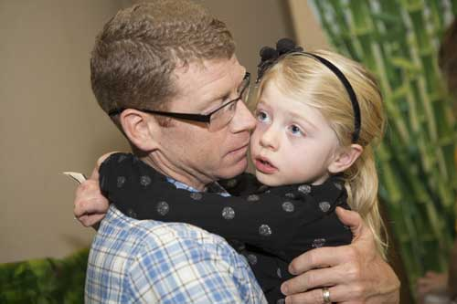

MOVIE

Title: The Lego Ninjago Movie
Genre: Animation, Action, Adventure
Rating: not yet rated (likely PG)
Cast: Olivia Munn, Jackie Chan, Fred Armisen, Justin Theroux, Dave Franco
Synopsis: This martial-arts action-comedy is the first film in the series to be based on an original Lego property, the Ninjago toy line. Six ordinary high school students by day become gifted ninja warriors by night, working to defend their island home. A warlord must deal with the fact that his son is one of the ninjas.
Our Take: This third “Lego” film to hit theaters will likely be clever and creative, while plugging a product in the process. Perilous situations may upset younger children, and some jokes may go over kids’ heads.
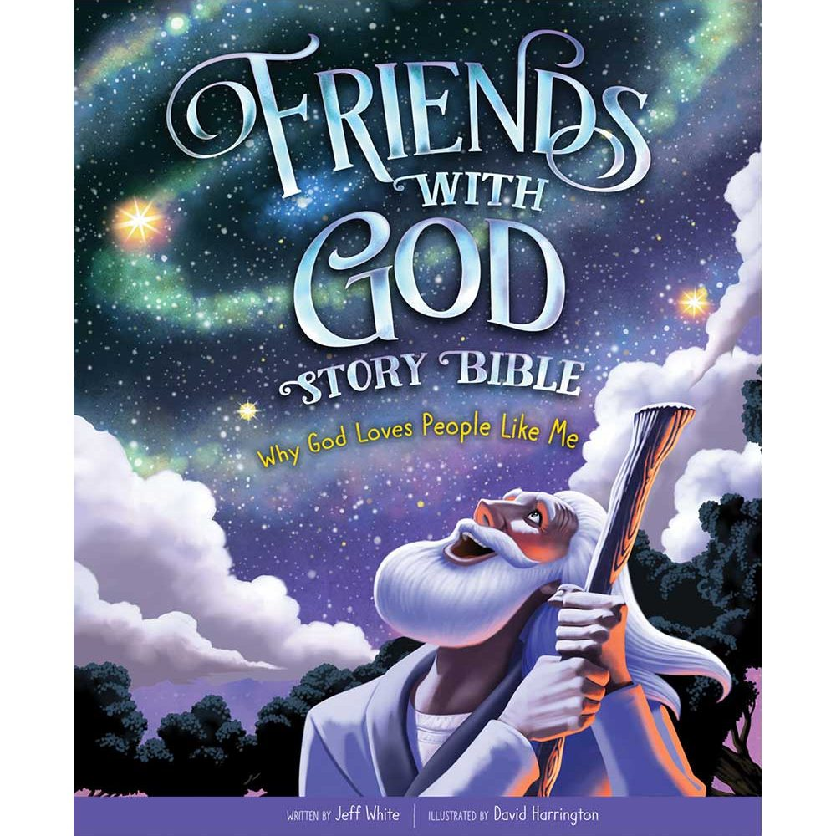
book

Title: Friends With God Story Bible
Author: Jeff White
Illustrator: David Harrington
Synopsis: This new story Bible is filled with 54 first-person accounts from the Old and New Testaments. Children meet Bible-times friends from their own points of view—and discover that they are God’s friends, too.
Our Take: This book is ideal for family devotions and bedtime reading. The thrilling true accounts and kid-friendly illustrations are sure to hold children’s attention. They’ll discover that God has always loved and worked through people just like them. As a bonus, the book comes with a free Bible app that lets children collect, share, and create digital trading cards for each character.

MEDIA MADNESS

CULTURE
& TRENDS
Dad Guilt on the Rise Now that fathers are more involved with day-to-day parenting, experts say they’re dealing with challenges such as dad guilt and stay-at-home dad envy. Plus, many fathers still feel pressure to be the family’s breadwinner. (today.com)

Grab a Seat! About 2,000 Buddy Benches now grace playgrounds at elementary schools throughout America. Each bench offers a safe place for children who are lonely and need friends. Often the idea—and fundraising—for the bench comes from young students themselves. (nbcnews.com; buddybench.org)

QUICK STATS
Learning at Home About 1.8 million American children are home-schooled. (nces.ed.gov)

A Twist on Bullying More than 30% of children report being bullied or harassed because of food allergies. Only half of parents knew the bullying was occurring. (Pediatrics)

Pet Love As many as 90% of kids live with a pet at some point during childhood. Research shows that young pet owners spend more time each week nurturing their animals than their younger siblings. (parents.com)

Games, Sites & Apps

Carrotia
This cooperative board game for up to six players involves creating mazes with tiles. The “master rabbit” must navigate to the exit in a certain number of steps while avoiding owls and hawks. The game also can be played untimed. Designed for ages 8+.

Text2Speech.org
If your child needs to have large chunks of text read aloud to him or her for school, text-to-speech software is a handy option. This free site lets you select the sound, speed, and volume of a voice. No registration is required, and you can use the speech files for any purpose.

OurPact
This free app for iPhone and Android lets parents control and schedule children’s screen time and block certain sites and apps. Parents can set up agreements with kids, granting screen time once chores are completed. They also can track their children through geolocation.

This page is designed to help educate parents and isn’t meant to endorse any movie, music, or product. Our prayer is that you’ll make informed decisions about what your children watch, read, listen to, and play.

September

SUNDAY | MONDAY | TUESDAY | WEDNESDAY | THURSDAY | FRIDAY | SATURDAY
 |  |  |  |  | 1 | 2
3  Pacesetters Lunch | 4  Labor Day- OFFICE CLOSED | 5 | 6 | 7 | 8 | 9
10  Grandparents Day  Ladies Tailgate Luncheon | 11  Patriot Day | 12 | 13 | 14 | 15 | 16
17  Widow’s Luncheon | 18 | 19 | 20 | 21 | 22  Fall Begins | 23
24 | 25 | 26 | 27 | 28  Lifetouch pictures | 29  Lifetouch pictures | 30  Lifetouch pictures

